**How to create road network dataset for the NDMVRP plugin?**

To just create a network dataset, one needs to follow the following set of instructions:

**To download road network layers**

Step 1: Download osm file from openstreetmap website > Export > Overpass API and download the OSM file of an area.

Step 2: Place the osm file in the folder “road extraction”. The folder is provided here in zip format. You have to extract and keep it as a folder. Use Winrar or some other archiving software for extracting.

Step 3: Open the “Code_for_uploading_filtered_maps.py” python file. Change line 35 according to your downloaded osm file’s name. for example, if your osm file is named “abc123.osm”, then the new line 35 of the python file should read as following:

map_name = "abc123"

Step 4: Save and exit the python file. You’ll get your road networks in 3 layers. Rename them to “Network_1”, “Network_2” and “Network_3” for the original file names containing “VT1”, “VT2” and “VT3” respectively.  
(The previous names of these layer were “road layer 1”, “road layer 2”, and “road layer 3” as may be indicated in some places in the Plugin manual. This has been changed to prevent the user from having a bias that the layers must be on similar modes. The PSR-GIP Heuristic allows any number of Multimodal Networks being used. The current Plugin User Interface has a limitation to presently allow a maximum of 3 Network layer inputs.)

Step 5: Now you just need to open them in QGIS, save them as **geopackage (.gpkg)** while keeping their names same and place your geopackage networks in a “**/Networks/**” directory within the plugin directory. The plugin directory is mentioned in the plugin manual.

**To generate modified road networks if disaster shapefile and original road network is given**

Step 1: Save the disaster shapefile as shapefile (.shp) file. Some associated files will be created in the process. Don’t delete them.

Step 2: Open the “code to remove affected features.py” python file in a python editor.   
Change the “road_layer_path = "your_road_layer" “line. For example, if it is placed in “D:\” in your pc, named “road layer 3.gpkg”, then the line would be:

road_layer_path = "D:/road layer 3.gpkg"

similarly, change the “flood_shapefile_path = "your_disaster_shapefile"” line. For example it could be:

flood_shapefile_path = "D:/chennai files/chennai floods.shp"

if the shapefile is “chennai floods.shp” placed in "D:/chennai files/”.

Step 3: Save the changes and run the python file through QGIS. The modified road network will be created in the same folder as the original as "Final_Road_Network.gpkg”. rename appropriately and use.

**Tips to remember**

* The file names have to be as mentioned. Changing the naming format will result in errors.  
  (The layer names must be of the appropriate names as indicated in the screenshot below. In the pictures below (Figure 1, Figure 2, and Figure 3), we show the drag and drop of already existing layers.)

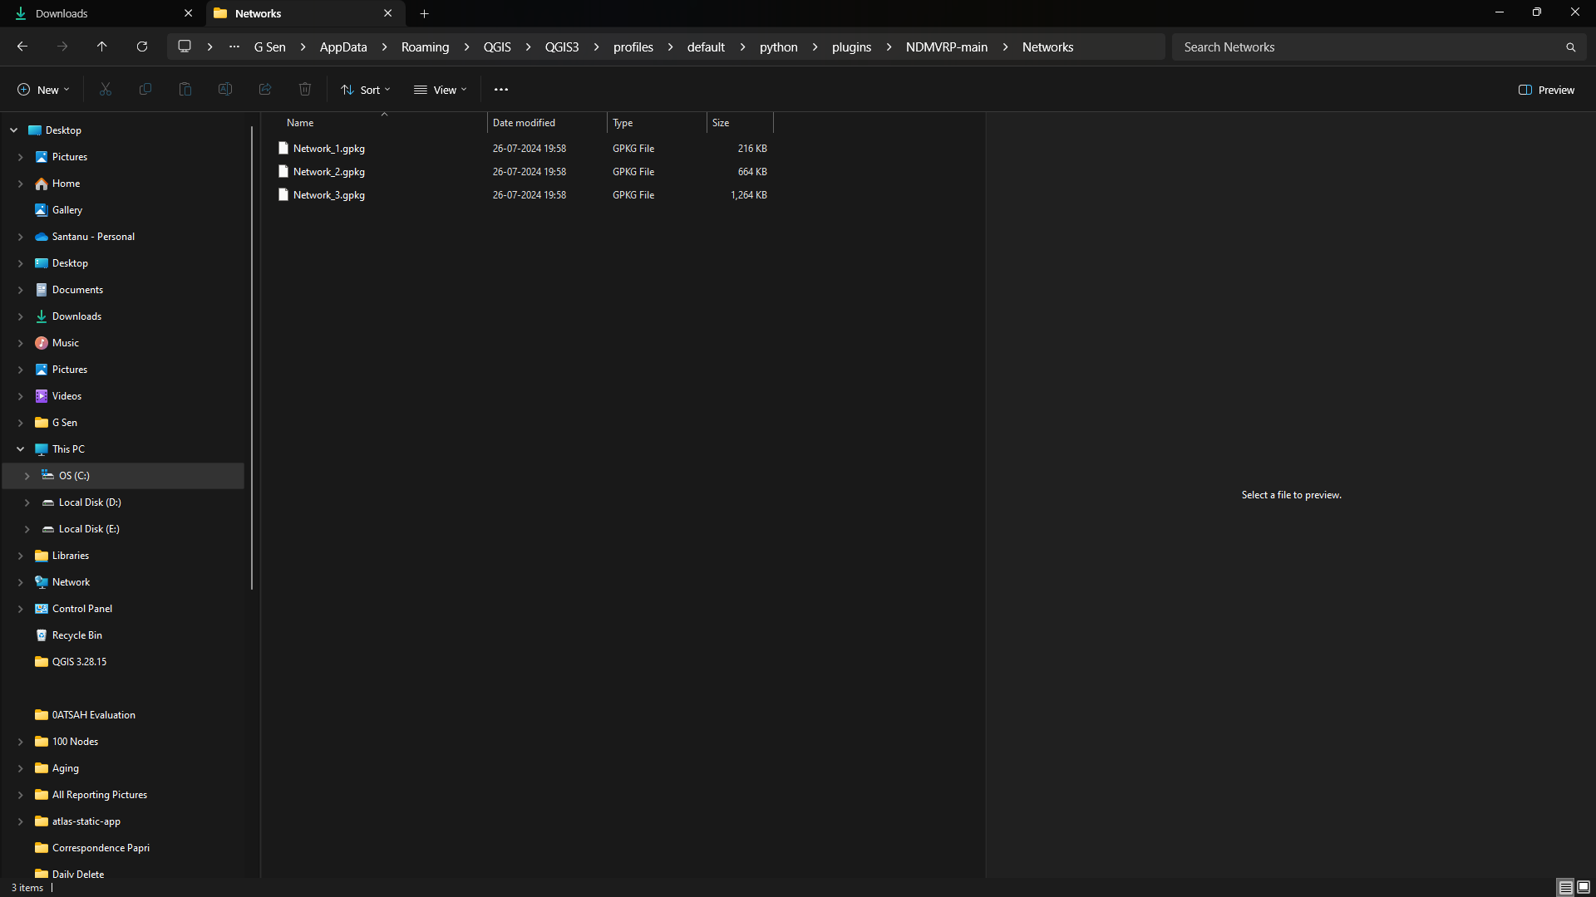

Figure 1: Showing the location of some Network layers already created by developers. The yellow circle shows the directory location where these Network layers should be placed.

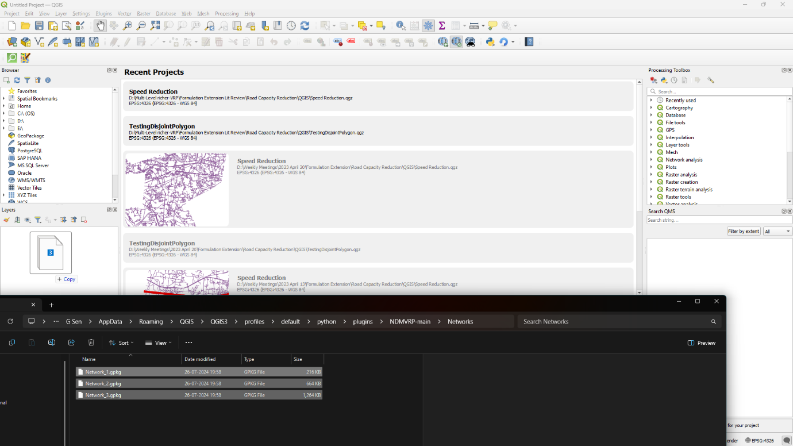

Figure 2: Showing the drag and drop of necessary Network layers to the QGIS layers panel. If the layers panel is not visible, press Ctrl+1 (to show or hide the layers panel within QGIS). The dragging action is showcased by the bold arrow.

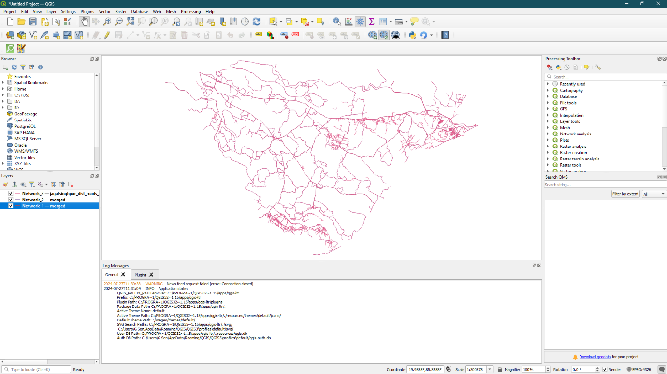

Figure 3: Showing the Network layers (maximum 3 layers are allowed; the added Network layers are circled in red in the above figure) added to the QGIS Layers panel after the drag-and-drop operation.

* The calculation time during run is dependent on network size. If a larger area is chosen, calculation time will be higher and if a smaller area is chosen, computational time will be lower.

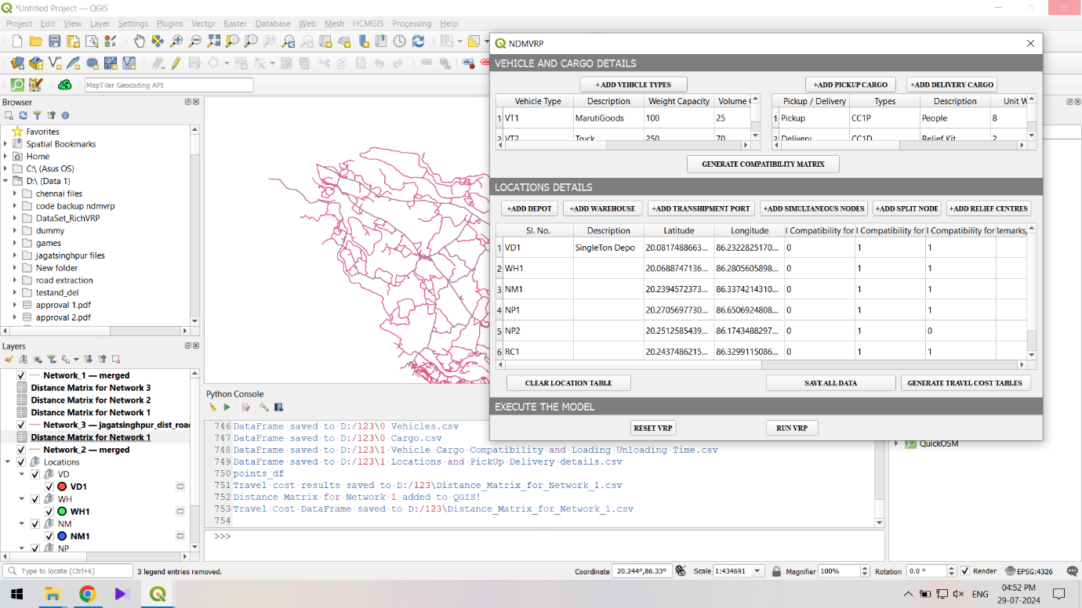

Figure 4: After clicking on "SAVE ALL DATA", and then clicking on "GENERATE TRAVEL COST MATRIX", the Network-wise Distance Matrices between all points will be generated. This figure showcases the Distance Matrices being generated (shown in red circle), after the distances for a network are calculated, they are save and a prompt is displayed (indicated as the red circle).

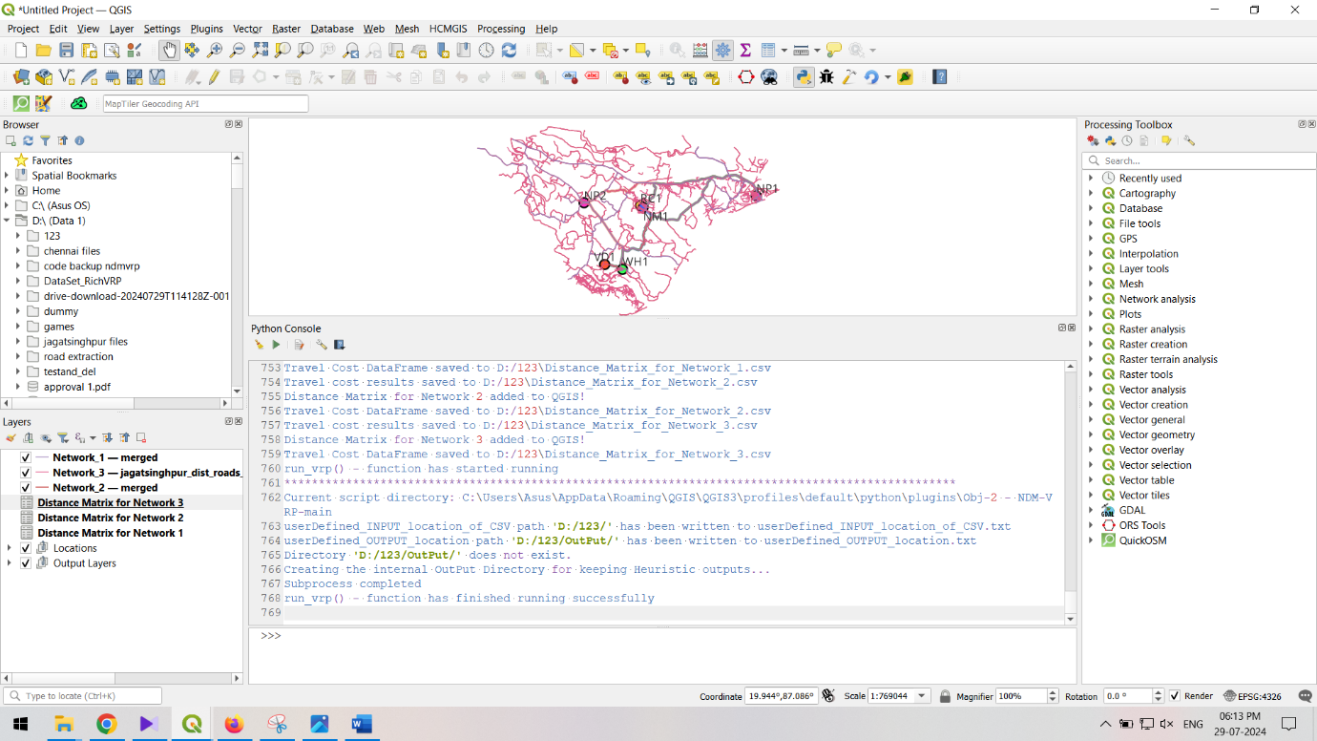

Figure 5: After all the distance matrices have been generated, all prompts of the corresponding distance matrix (.csv) files being saved will be shown (indicated in the red circled region). Then the "RUN VRP" button will start the Heuristic.

Currently the Travel Times Matrices are calculated using Dijkstra’s Algorithm which may be upgraded to A* algorithm or better strategies subsequently.

* For better elimination of affected road network, you can always ensure the original road networks are appropriately segmented. You can do it by processing the road network through “Processing toolbox” > “split with lines” feature in QGIS.  
  Save the resulting road network and use it for elimination of affected road segments.